

Capstone Project Report

E-Governance Grievance Redressal System
By : Kanchan Rai

Deployed with Azure VM

The following document contains the description and explanation of the project E-Governance Grievance Redressal System. This project has all the required requirements of the project. The project has been developed using SpringBoot 3.2.5 , Angular 21, Jenkins, Docker, JUnit, Azure VM

INDEX

1. Project Over View
1.1 Frontend Authorization Flow
2. Endpoints and Website flow
2.1 Admin Panel and User Home Page
2.2 Search Flights
2.3 Login / Sign Up

1. Project Overview
Government departments receive numerous citizen grievances related to public services, which are often handled manually, causing delays and lack of transparency. The E-Governance Grievance Redressal System is a centralized Java-based application that enables online grievance submission, tracking, and efficient resolution, improving transparency, accountability, and service delivery.

The proposed E-Governance Grievance Redressal System is a centralized, web-based Java application that allows citizens to submit and track grievances online. It automatically routes complaints to the appropriate departments, monitors the grievance lifecycle, and provides real-time status updates and dashboards to ensure transparency, accountability, and timely resolution.

The scope of the system includes online grievance registration, tracking, assignment, and resolution across multiple government departments.

There are 5 user roles -
- Citizen - Submits and tracks grievances
- Admin - Managers staff users, manages departments
- Department Officer - Each department has one officer who manages grievances and assigns them to case workers
- Case Worker - Multiple per department resolve grievances
- Supervisory Officer - View and Handle Escalations
1.1 Architecture Diagram

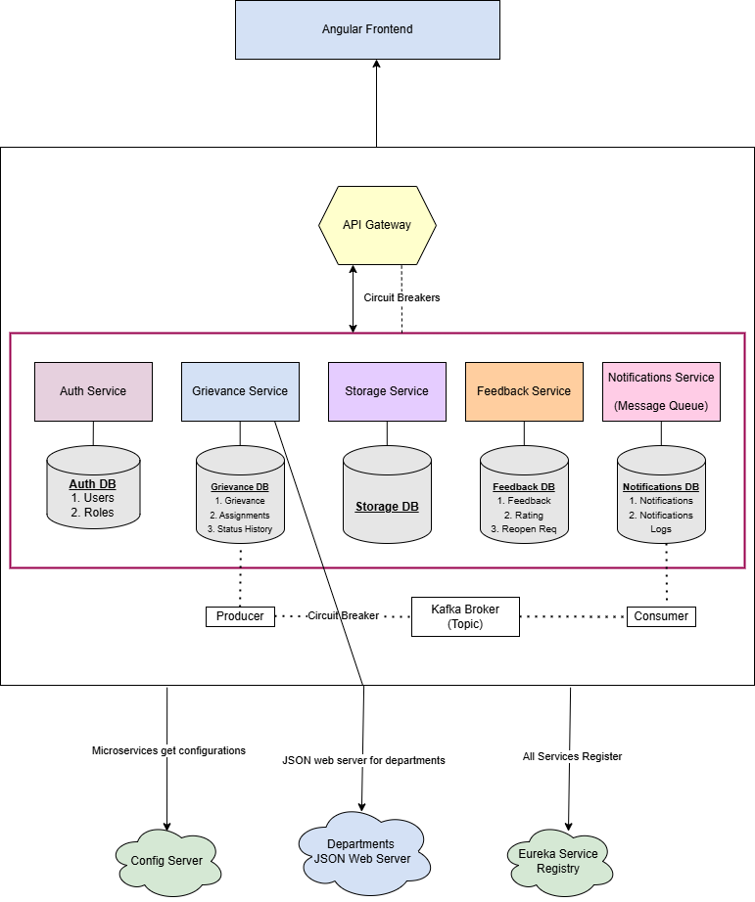

This web application has 5 core microservices Auth Service, Grievance Service, Storage Service, Feedback Service and Notifications Service

To store departments a JSON server is used. These services talk to each other through API Gateway by registering themselves on Eureka Server.

If one microservice fails so the ones don’t fail circuit breaker has also been utilized. To send notifications Kafka Message Broker is also used.

2. Sonarqube Report & Unit Testing

2.1 Sonarqube Report
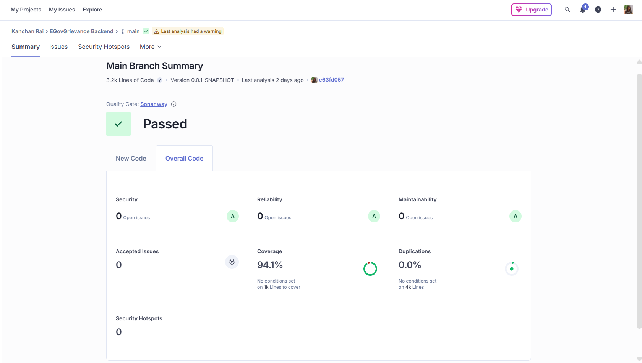

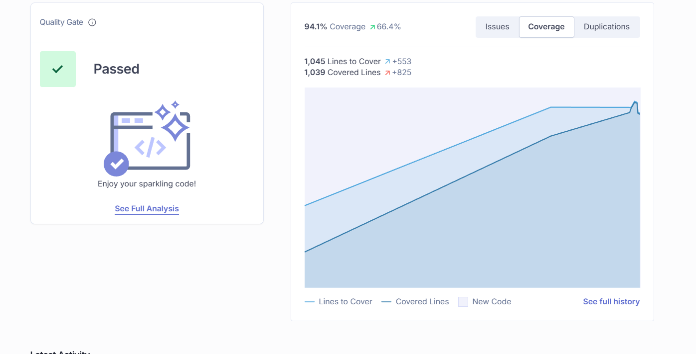

3. Jenkins Pipeline

3.1 Set in github webhooks for CI/CD

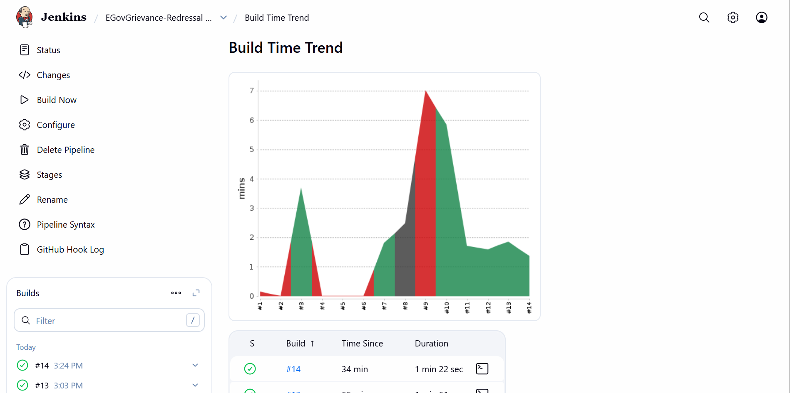

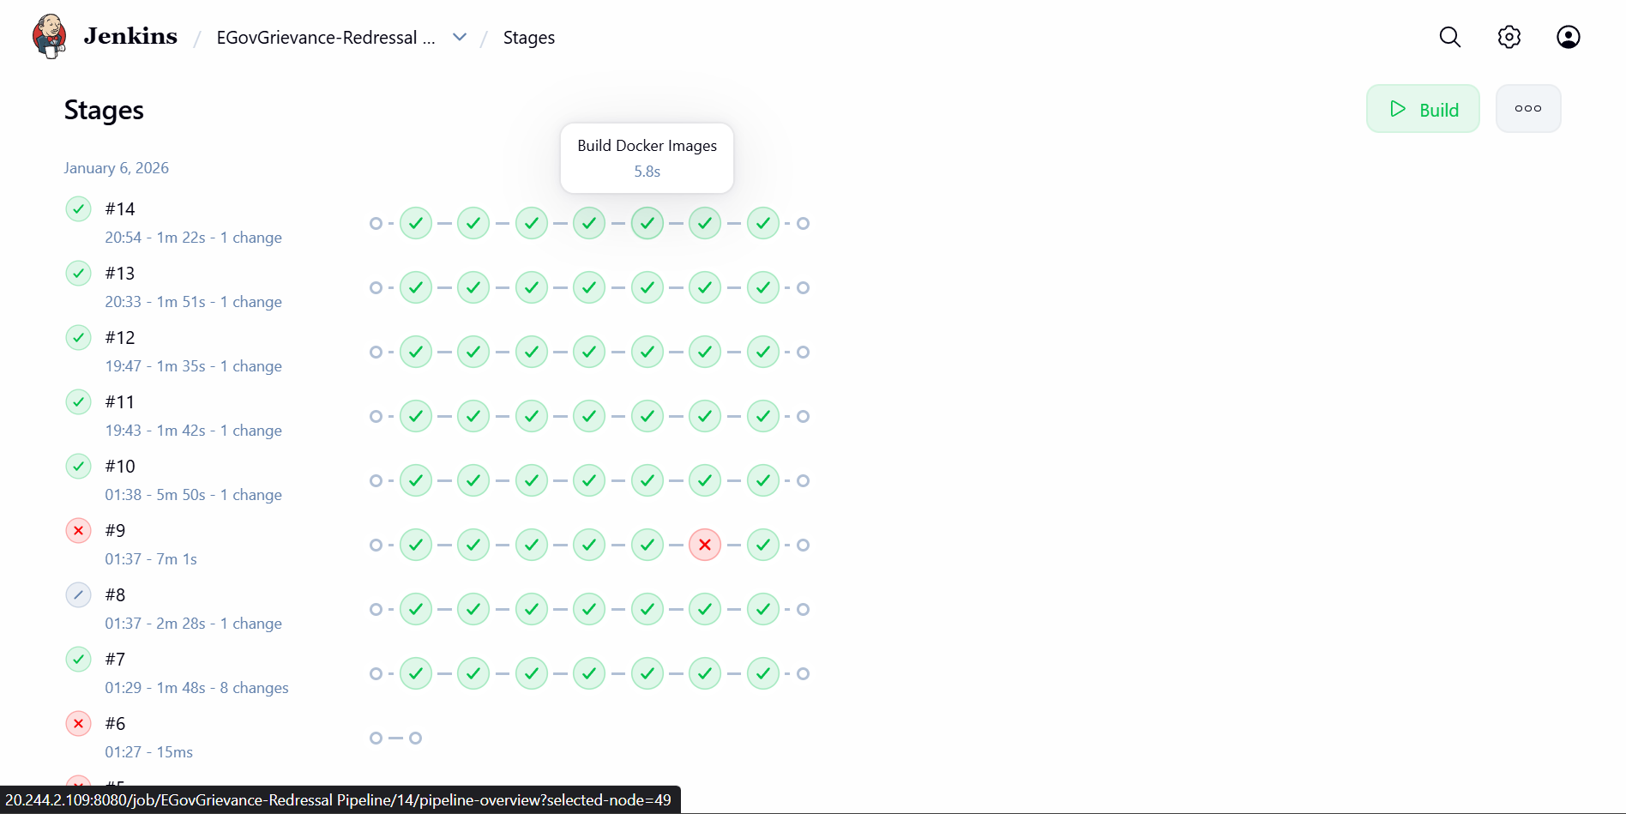

4. Deployment in Azure VM

4.1 Azure VM Dashboard - VM IP - 20.244.2.109

The VM is a Linux OS

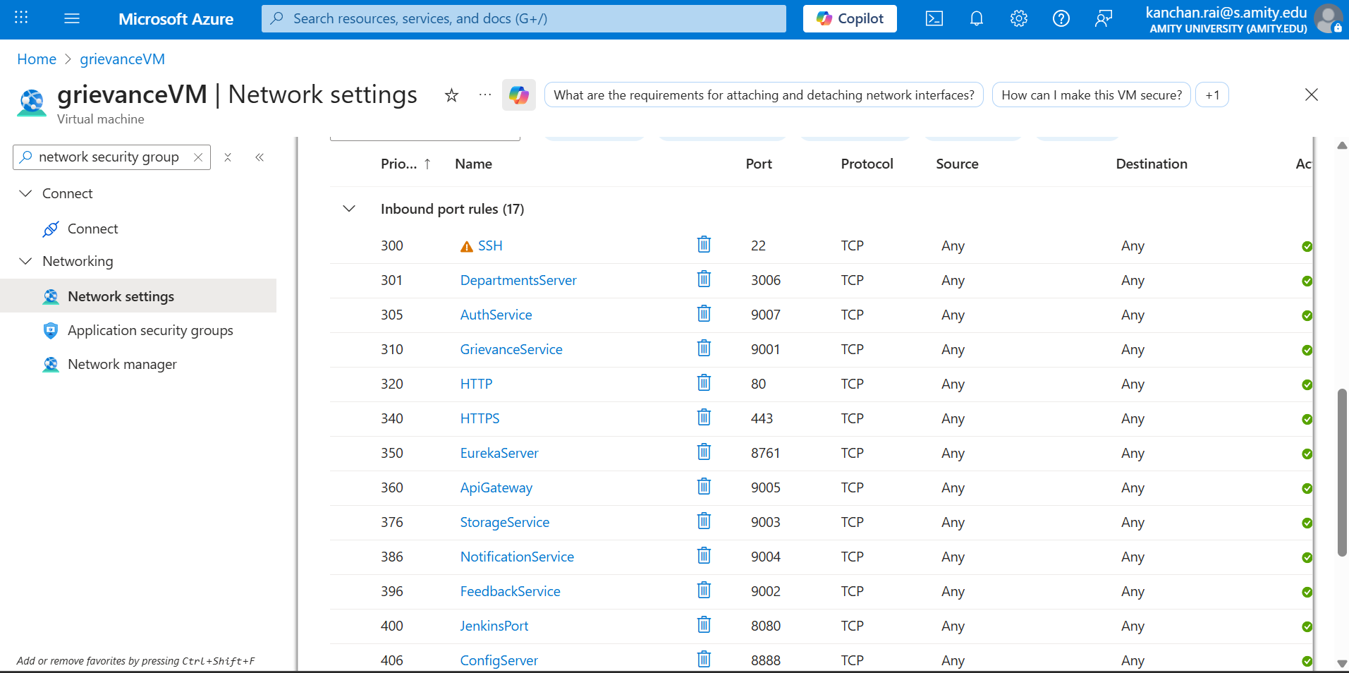

4.2 Docker Containers Running In VM - “docker ps”
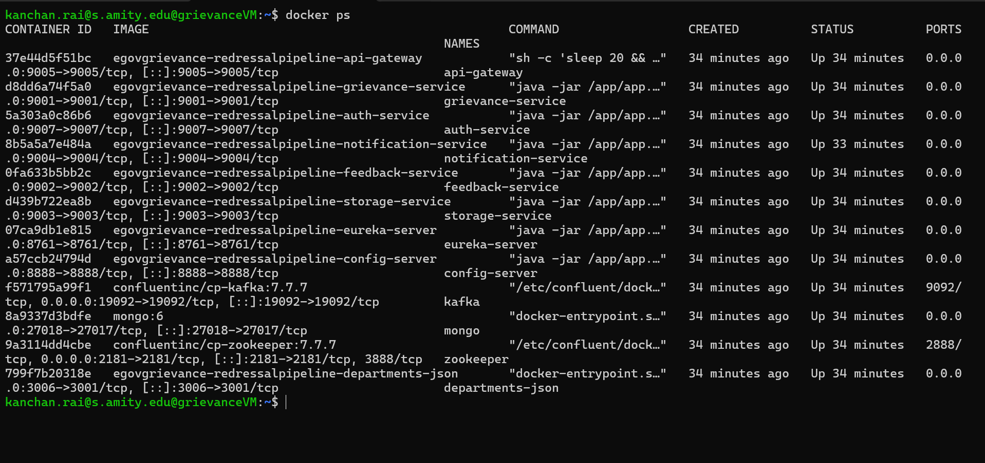

5. Frontend Deployment

6. Postman Collections Overview - User View

6.1 User Login with Validations

Invalid Credentials Scenario
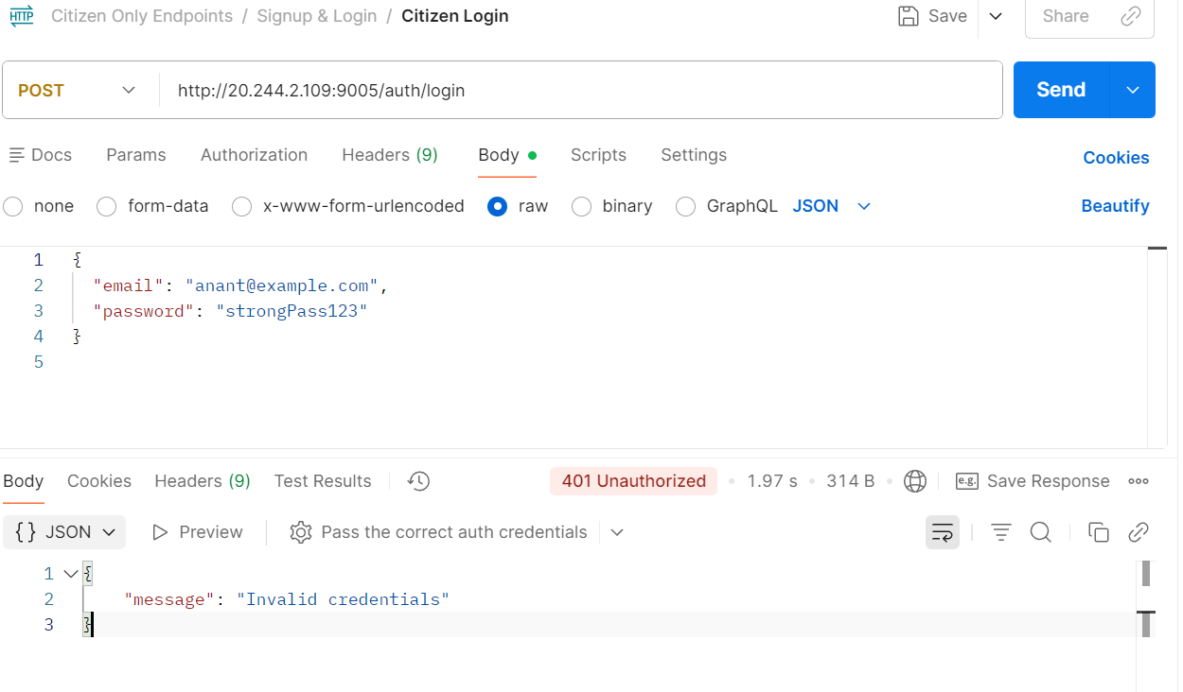

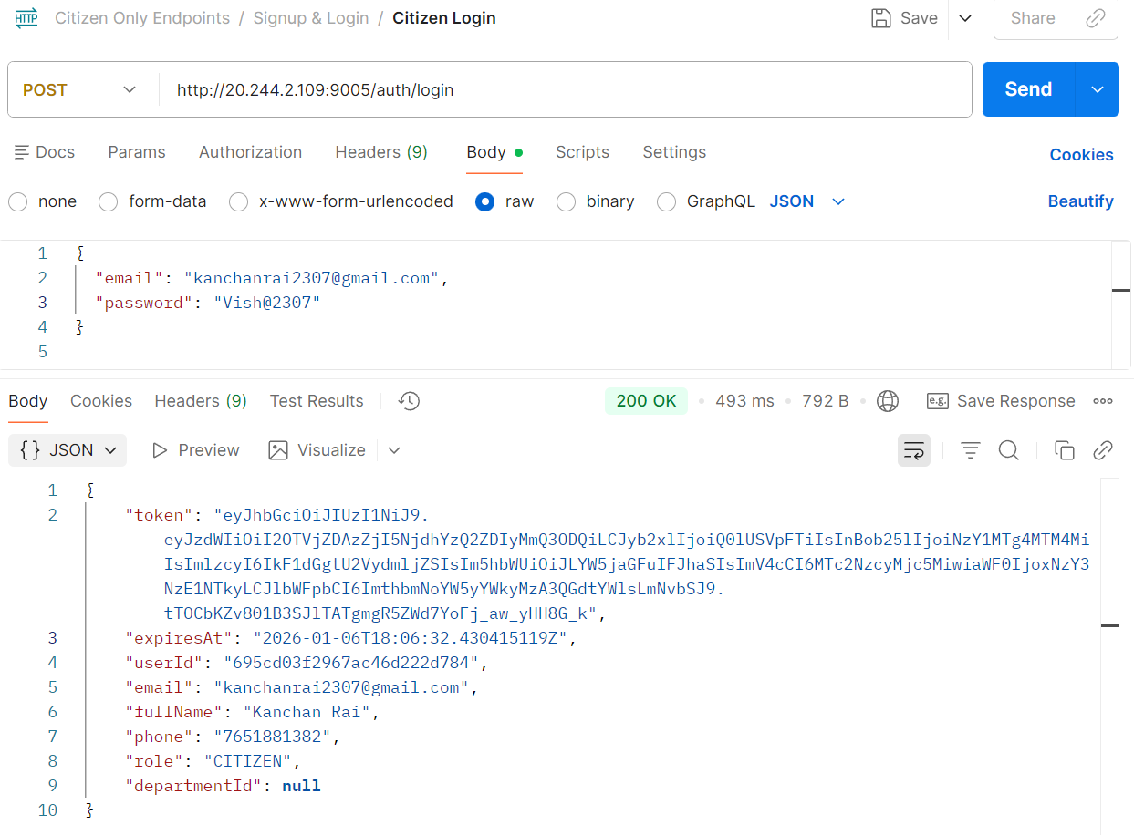
Valid Login

User Registration with Validation - User already exists
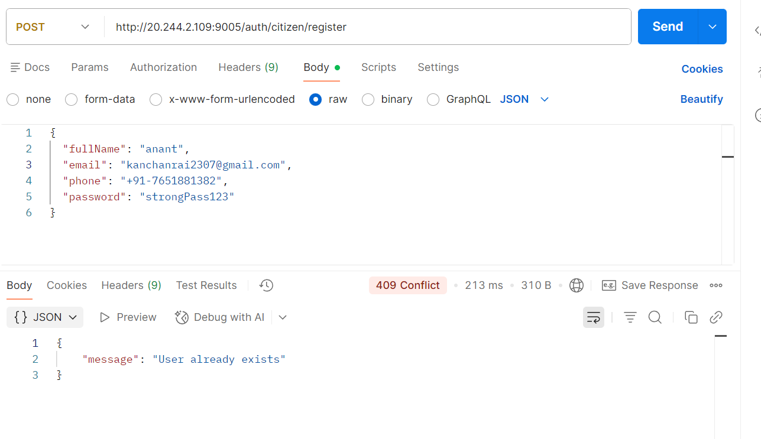

Successful User Creation
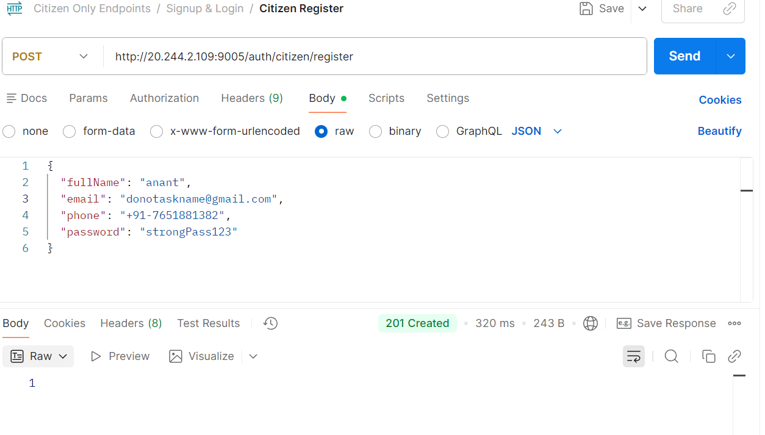

Lodging a grievance
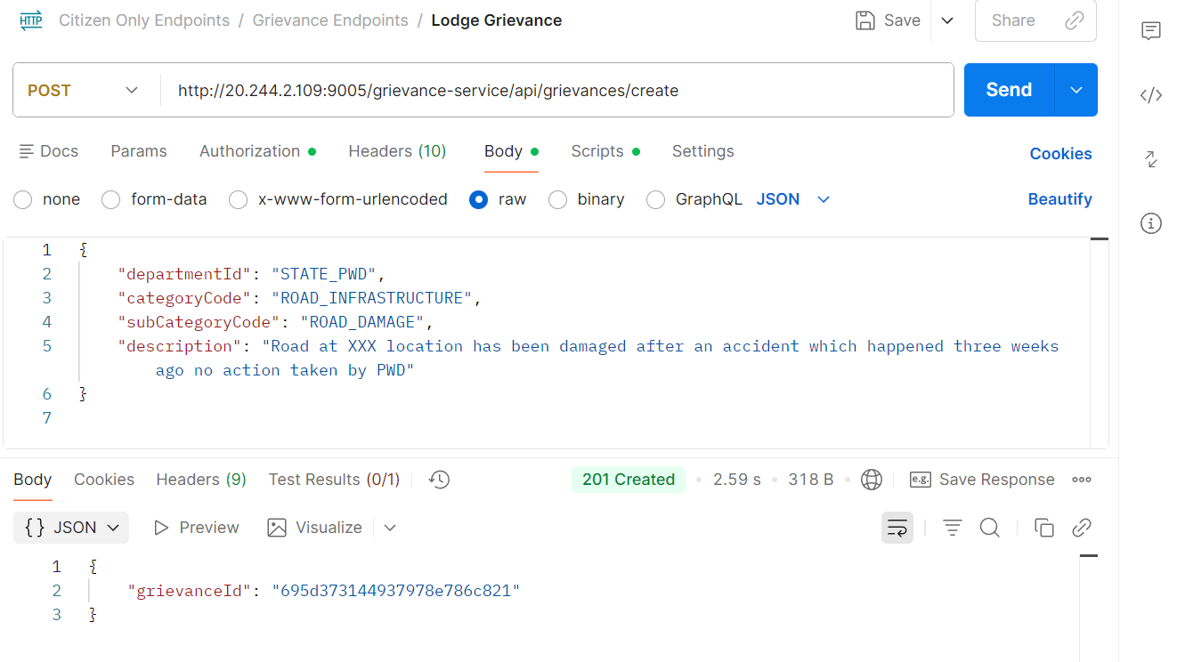

Checking the status
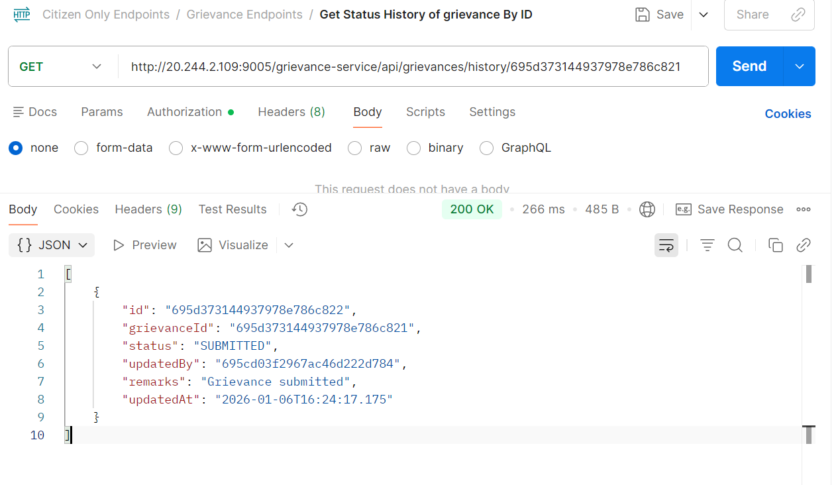

7. Angular Frontend

